**Devops – Final Assessment**

**Section 1: Multiple-Choice Questions (MCQs)**

1. What does WSL stand for in the context of Windows?

Ans: c. Windows Subsystem for Linux

2. What is the primary goal of continuous integration (CI) in DevOps?

Ans: b. Frequent integration of code changes

3. In the Linux command line, what does the cd command do?

Ans: b. Change the working directory

4. Which of the following is not a Linux distribution?

Ans: c. Docker

5. What is Docker primarily used for in DevOps and containerization?

Ans: c. Packaging and deploying applications in containers

6. What is the primary purpose of Azure DevOps?

Ans: b. Software development and delivery

7. Which components are part of Azure DevOps?

Ans: c. Azure Boards and Azure Pipelines

8. How does Azure DevOps support version control in software development?

Ans: b. It tracks changes in source code and manages versions.

9. In Linux, what is the primary role of the root user?

Ans: c. Administrative tasks with superuser privileges

10. In Azure DevOps, which component is used to define, build, test, and deploy

applications? Ans: c. Azure Pipelines.

**Section 2: Labs**

**Lab 1: File and Directory Management**

Objective: Practice basic file and directory management commands.

Tasks:

1.Create a directory called "lab1" in your home directory.

2.Inside "lab1," create a text file named "sample.txt" with some content.

3.Make a copy of "sample.txt" and name it "sample_copy.txt."

4.Rename "sample_copy.txt" to "new_sample.txt."

5.List the files in the "lab1" directory to confirm their names

Ans:

1. To create a directory, use mkdir command.

Eg: mkdir lab1

2. Now, list the directories using ls, move to lab1 using cd, create a file using touch.

Eg: ls

Eg: cd lab1

Eg: touch sample.txt

3. Make a copy of sample.txt and name it sample_copy.txt using cp

Eg: cp sample.txt sample_copy.txt

4. Rename it to new_sample.txt using mv

Eg: mv sample_copy.txt new_sample.txt

5. List using ls.

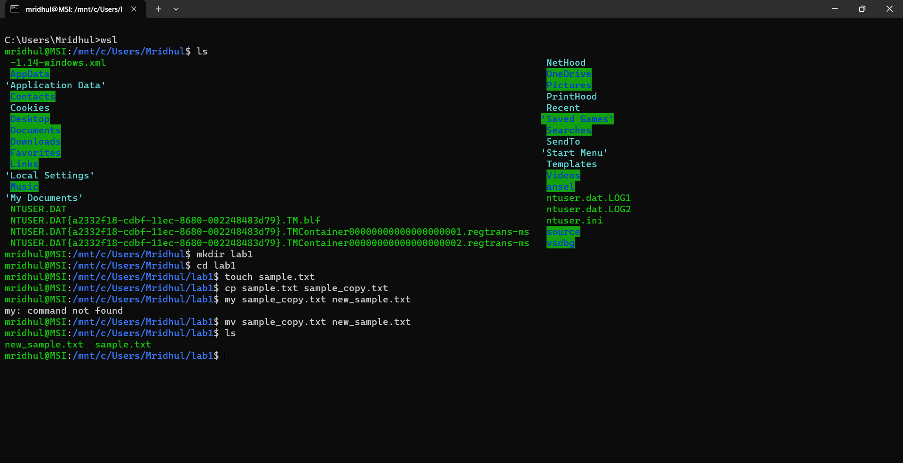

**Lab 2: Permissions and Ownership**

Objective: Understand and manage file permissions and ownership.

Tasks:

1.Create a new file named "secret.txt" in the "lab2" directory.

2.Set the file permissions to allow read and write access only to the owner.

3.Change the owner of "secret.txt" to another user.

4.Verify the new permissions and owner using the ls -l and ls -n commands.

Ans:

1. Create new file using touch

Eg: touch secret.txt

2. Set file permissions to allow read, write access using chmod 600

Eg: chmod 600 secret.txt

3. Change owner using chown

Eg: chmod mahasri:mahasri secret.txt

4. Verify new permission using ls -l , ls -n

Eg: ls-l secret.txt and ls-n secret.txt

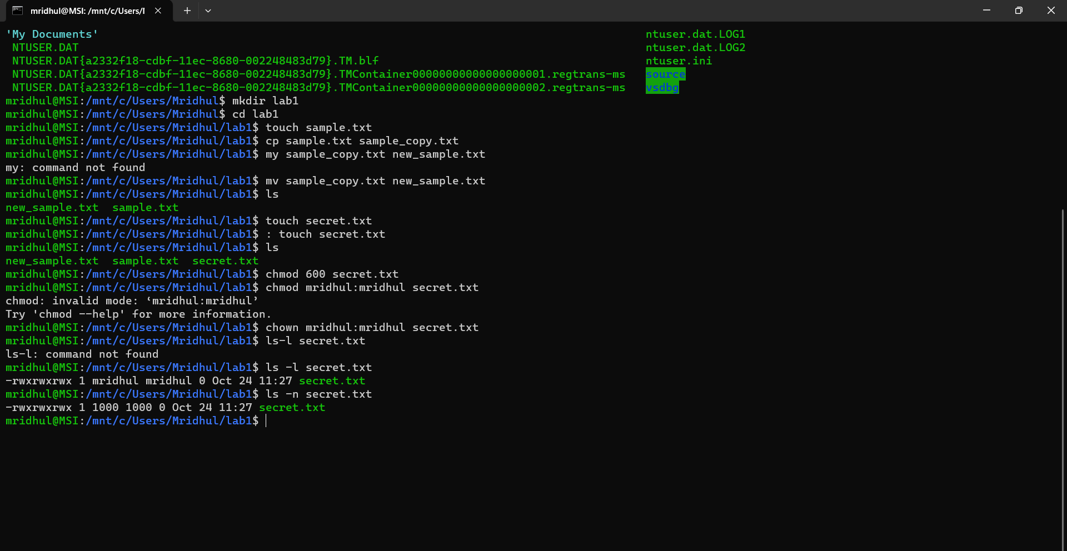

**Lab 3: Text Processing with Command Line Tools**

Objective: Practice text processing using command-line tools.

Tasks:

1.Create a text file with some random text in the "lab3" directory.

2.Use the grep command to search for a specific word or pattern in the file.

3.Use the sed command to replace a word or phrase with another in the file.

4.Use the wc command to count the number of lines, words, and characters in the file.

Ans:

1. Create text file using touch

Eg: touch sample.txt

2. Use grep to search for a word

Eg: grep "kanini" sample.txt

3. Use sed to replace a word

Eg: sed -i "s/Mahasri/Maha/g" sample.txt

4. Use wc to count no.of lines

Eg: wc sample.txt

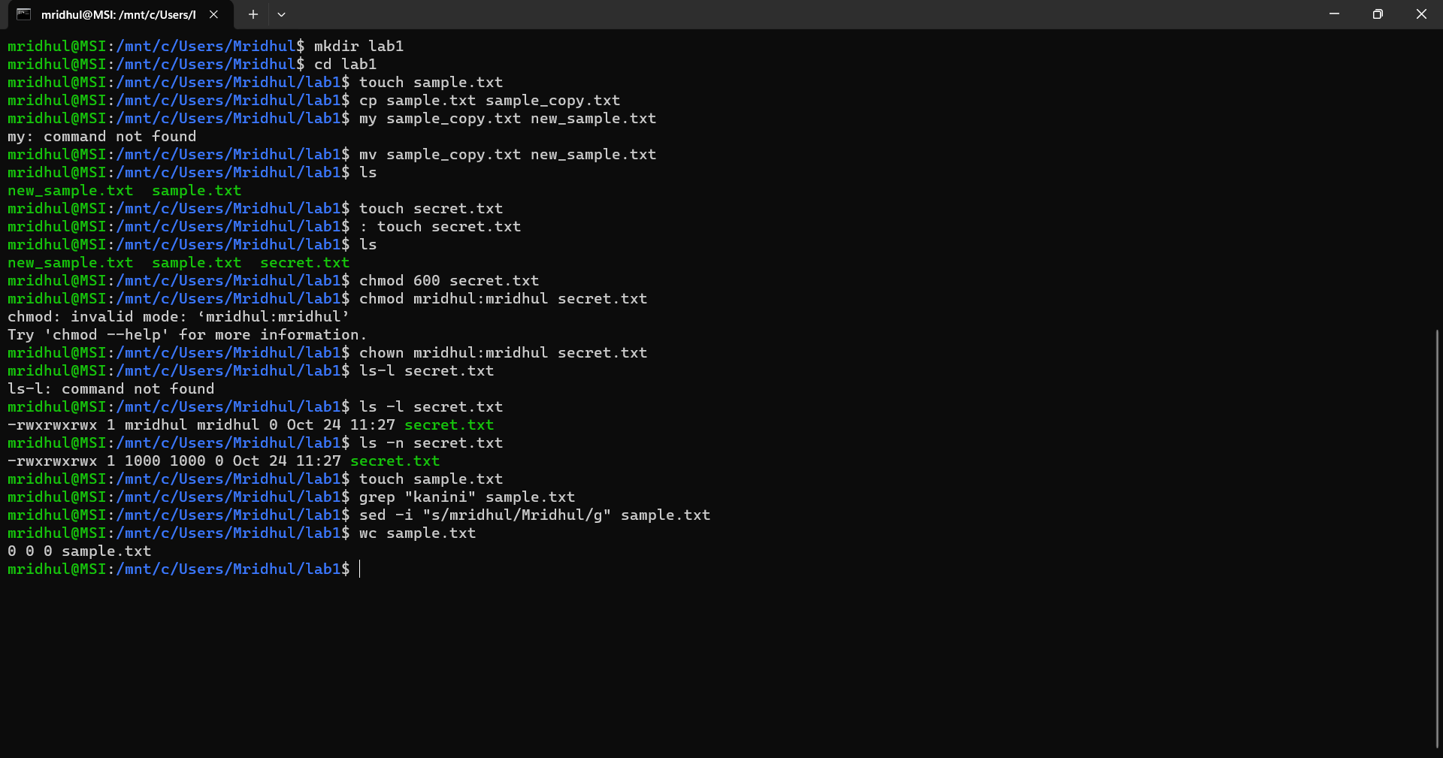

**Lab 4: Creating a Simple YAML File**

Objective: Create a basic YAML configuration file.

Task:

1.Create a YAML file named "config.yaml."

2.Define key-value pairs in YAML for a fictitious application, including name, version,

and description.

3.Save the file.

4.Validate that the YAML file is correctly formatted.

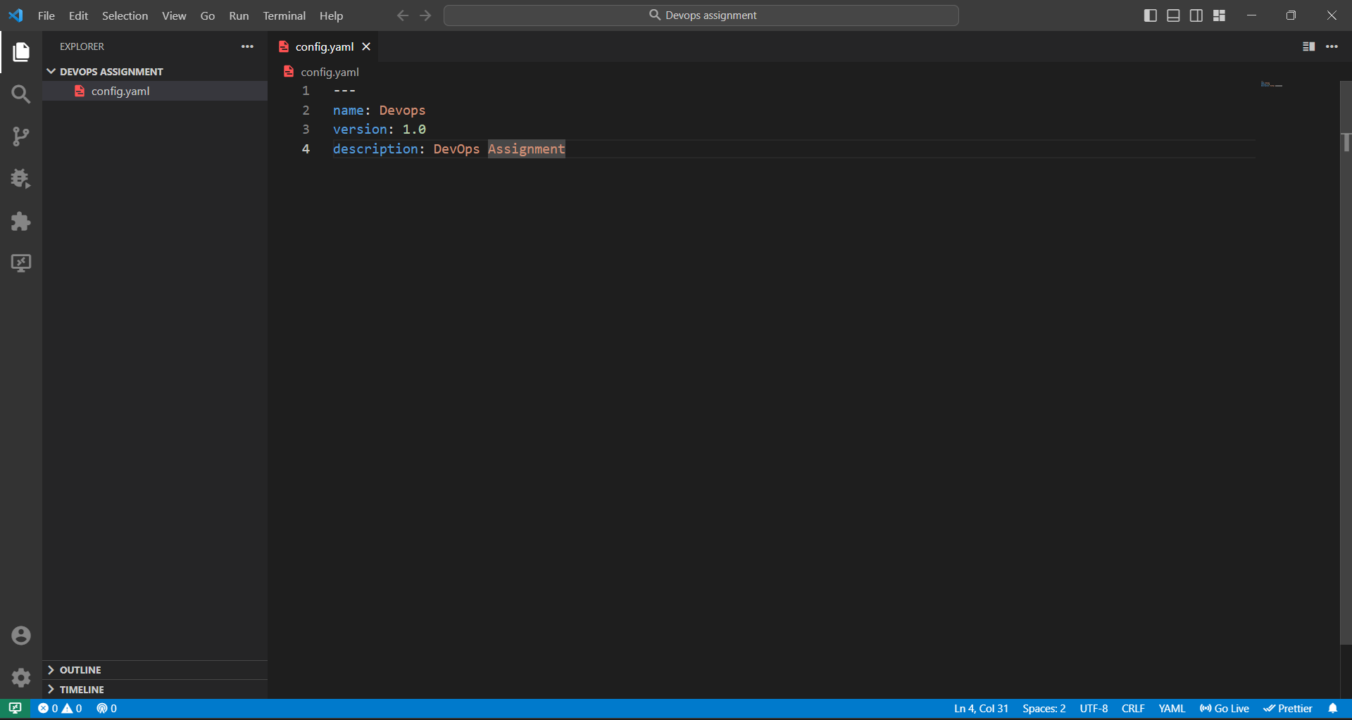



**Lab 5: Working with Lists in YAML:**

Objective: Practice working with lists (arrays) in YAML.

Task:

1.Create a YAML file named "fruits.yaml."

2.Define a list of your favorite fruits using YAML syntax.

3.Add items from the list.

4.Save and validate the YAML file.  
  
ANS

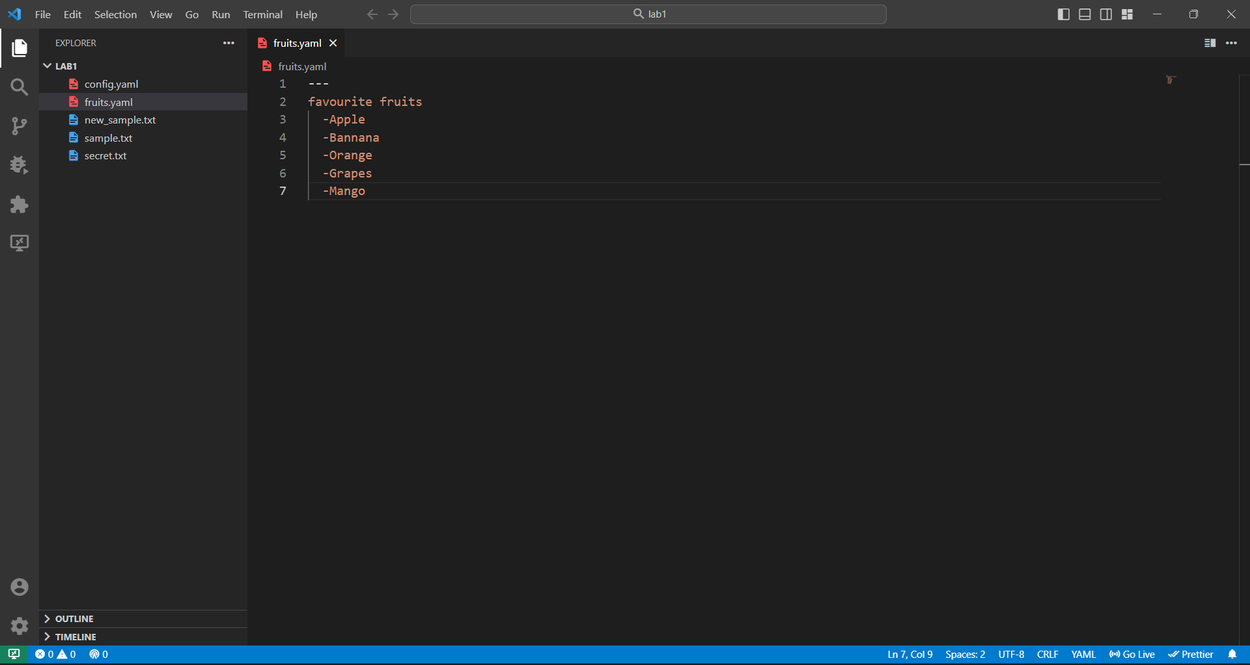

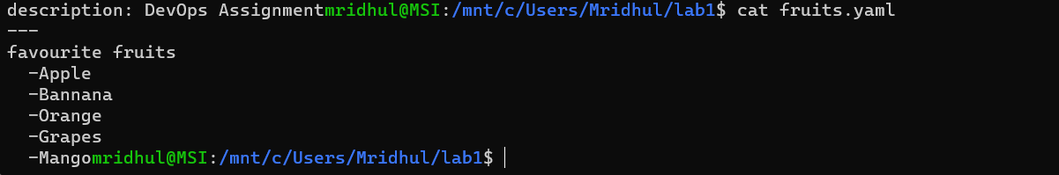

**Lab 6: Nested Structures in YAML**

Objective: Explore nested structures within YAML.

Task:

1.Create a YAML file named "data.yaml."

2.Define a nested structure representing a fictitious organization with departments and

employees.

3.Use YAML syntax to add, update, or remove data within the nested structure.

4.Save and validate the YAML file.

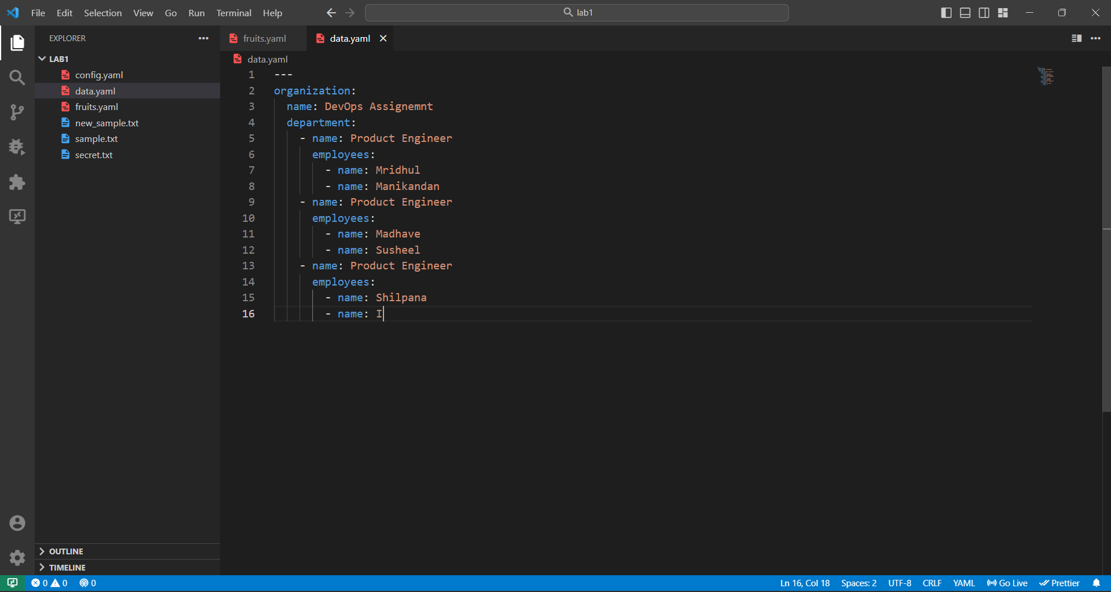

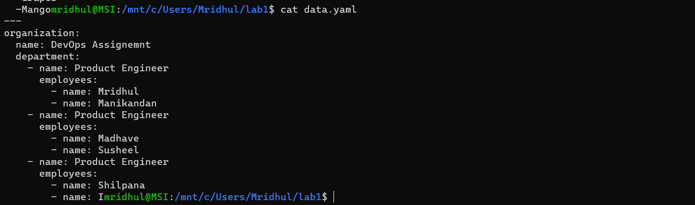

**Lab 7: Create Classic Azure CI Pipeline for Angular Application**

Objective: Set up a classic Azure CI pipeline to build a simple Angular application with unit

testing using Jasmine and Karma.

Tasks:

1.Create an Azure DevOps project.

2.Set up a classic CI pipeline to build an Angular application.

3.Configure the pipeline to use Jasmine and Karma for unit testing.

4.Run the pipeline and validate the test results.

Ans:

Create pipeline using classic editor:

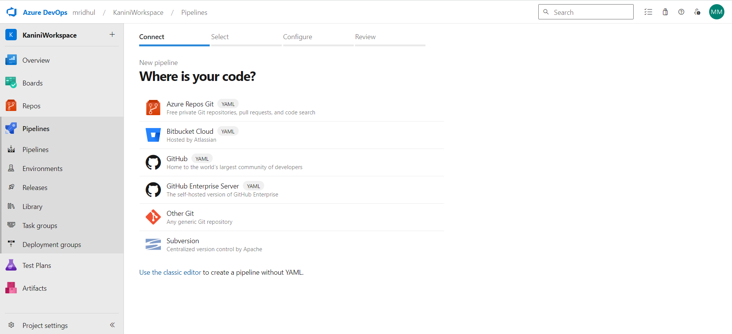

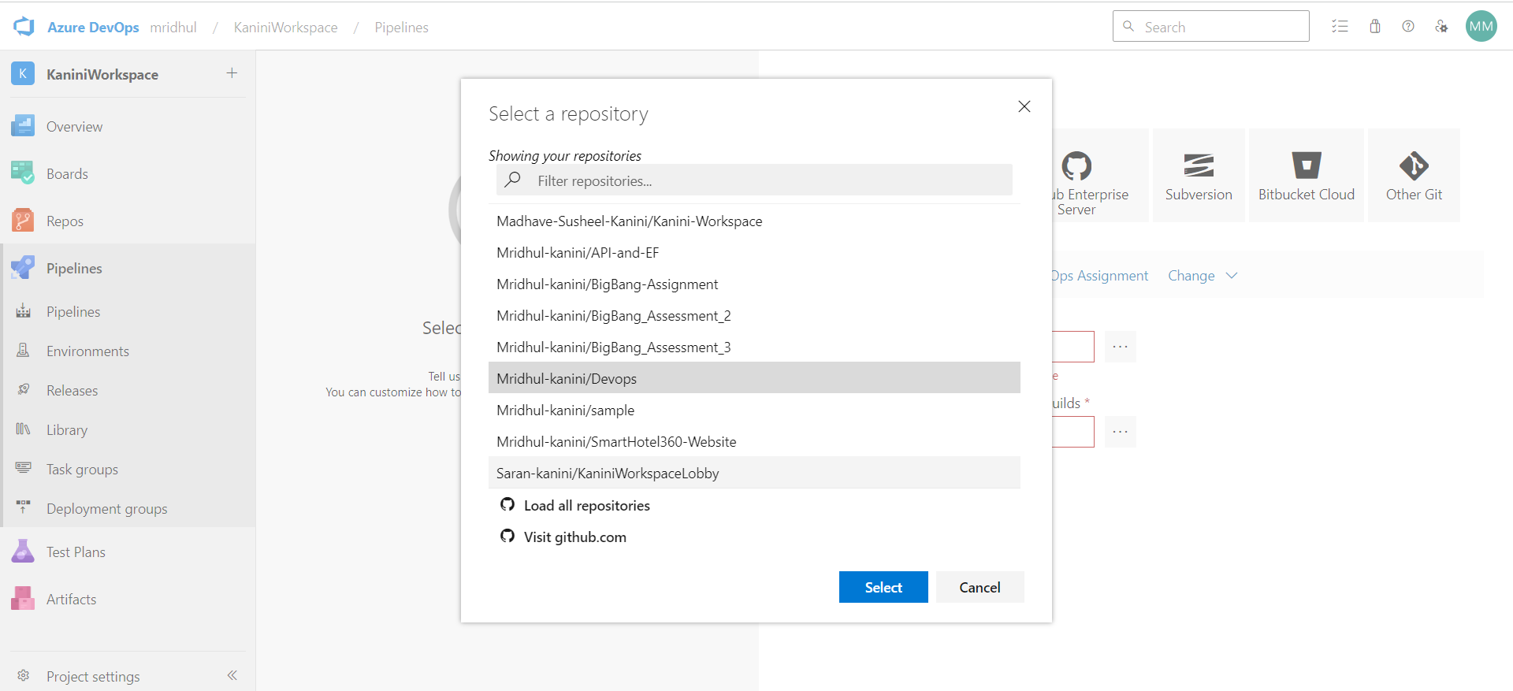

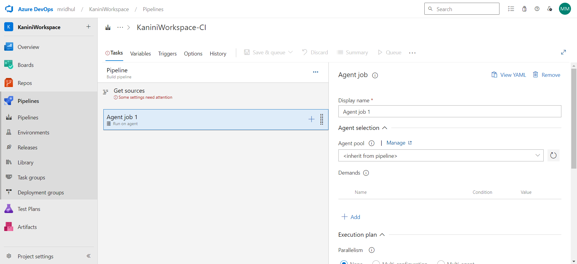

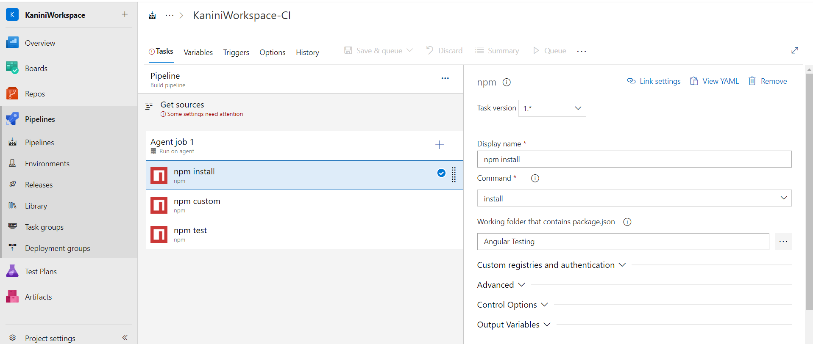

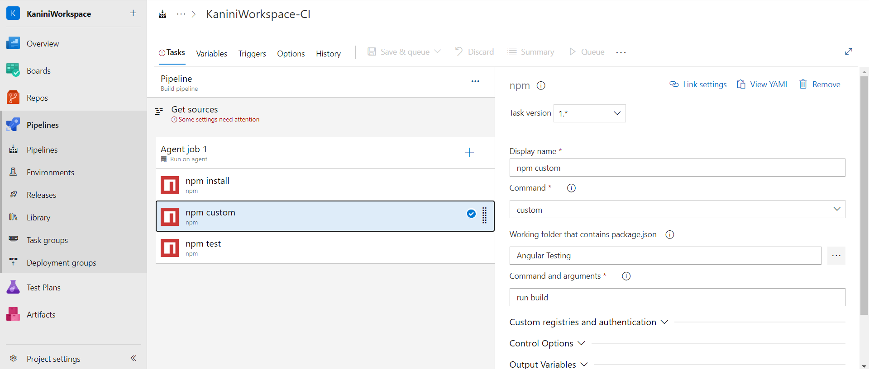

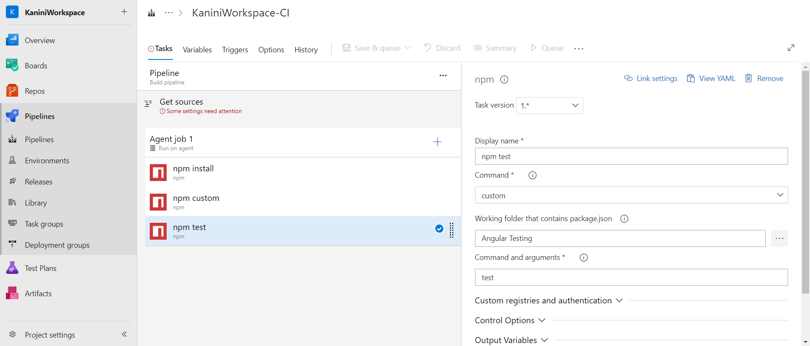

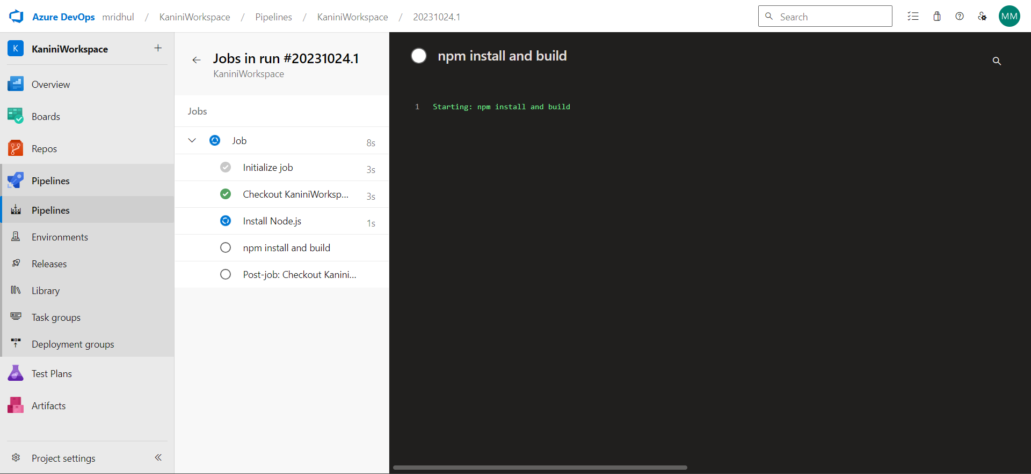

**Lab 8:Create YAML Azure CI Pipeline for React Application**

Objective: Create a YAML-based Azure CI pipeline to build a simple React application with

unit testing using Enzyme and Jest.

Tasks:

1.Create an Azure DevOps project.

2.Create a YAML-based CI pipeline to build a React application.

3.Configure the pipeline to use Enzyme and Jest for unit testing.

4.Trigger the pipeline and verify the test results.

Create New Pipeline

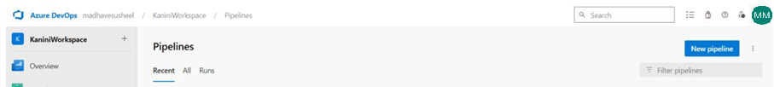

Choose Github

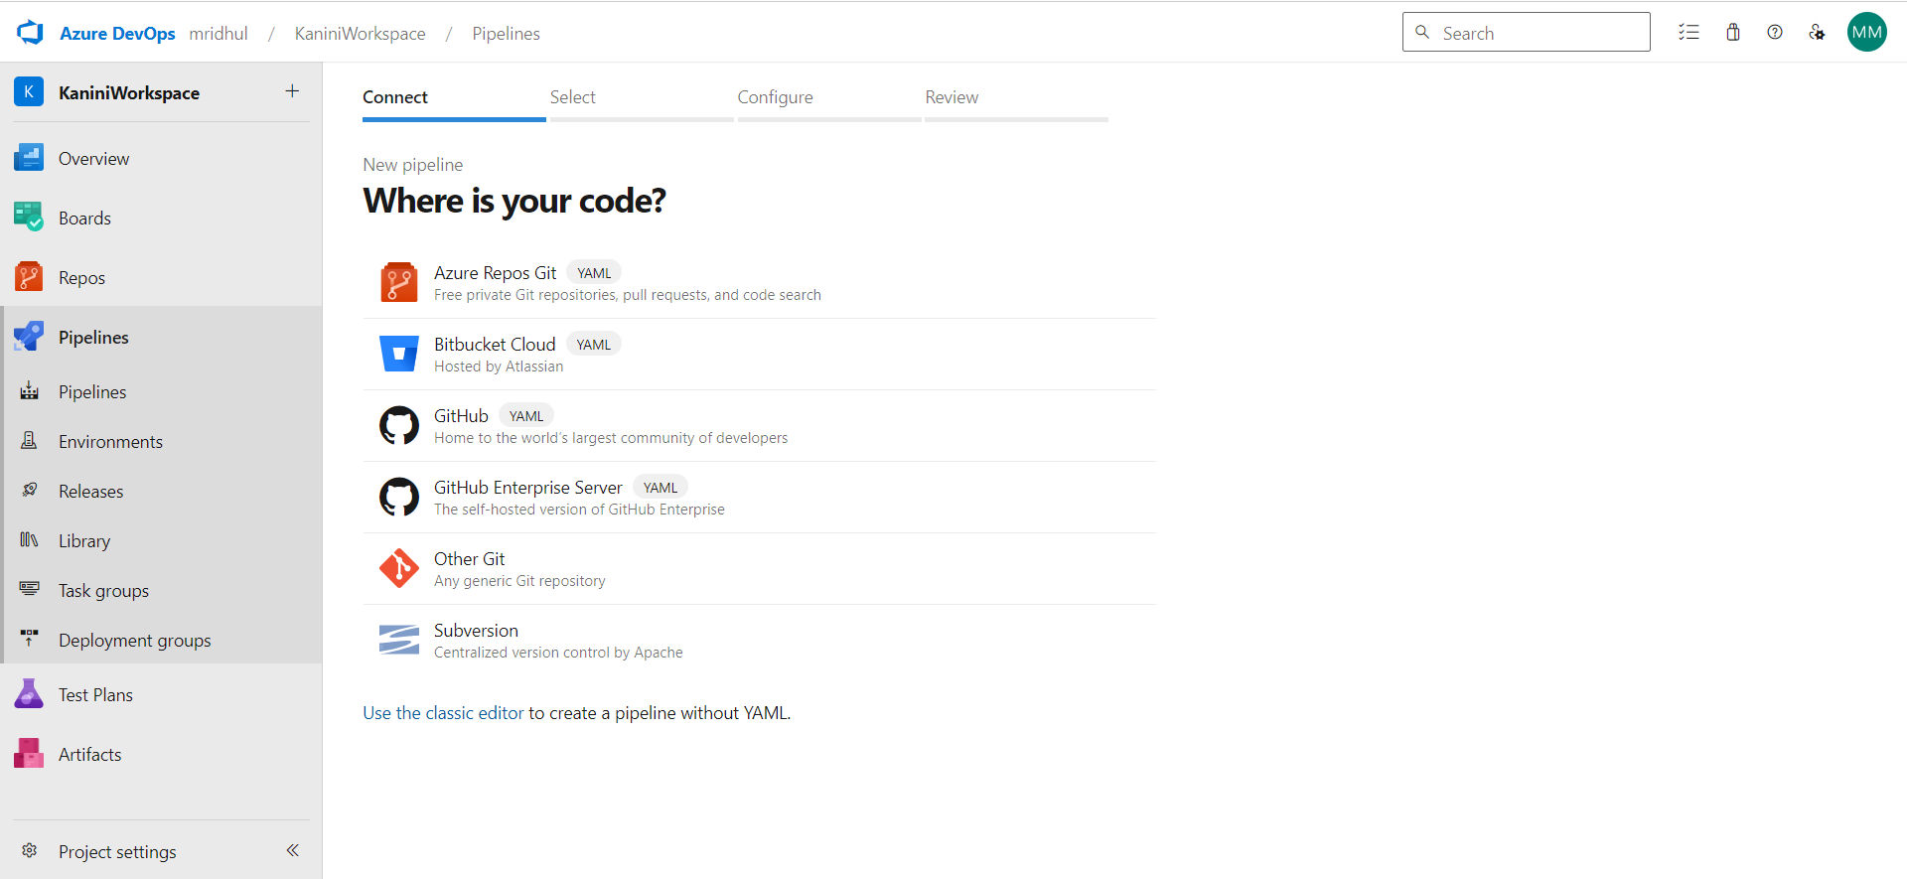

Choose a repo

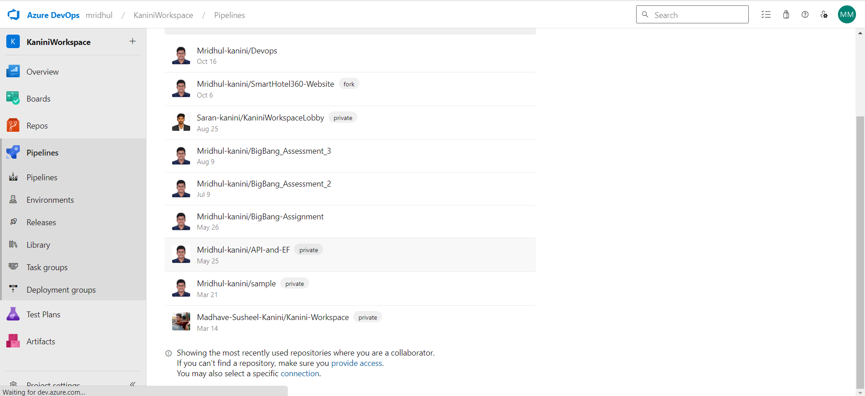

Edit Yaml

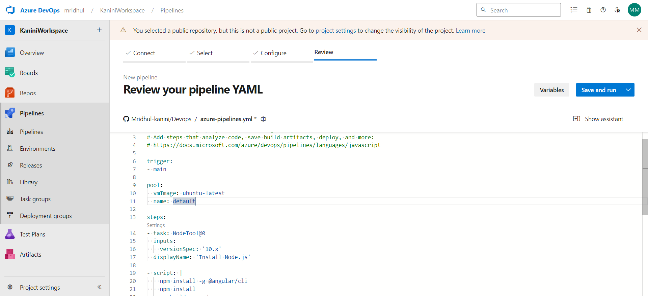

Save and Run

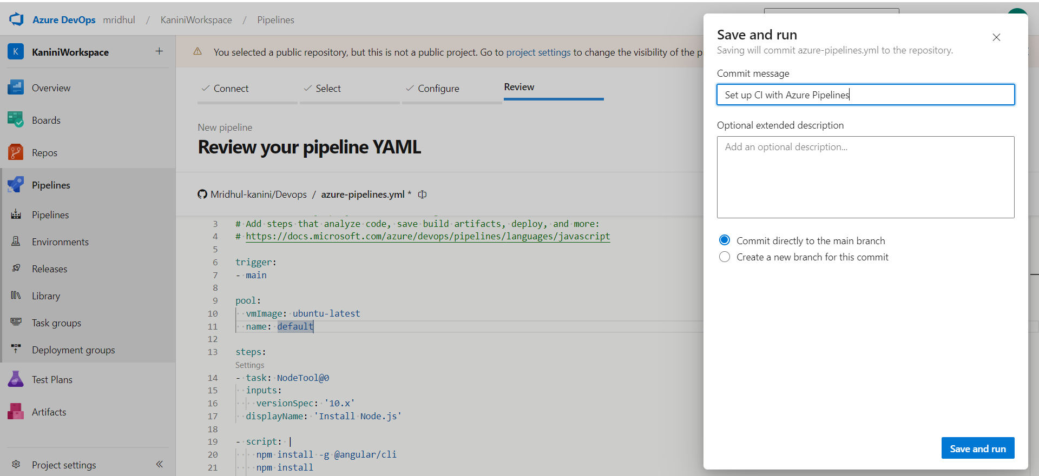

Give Permission

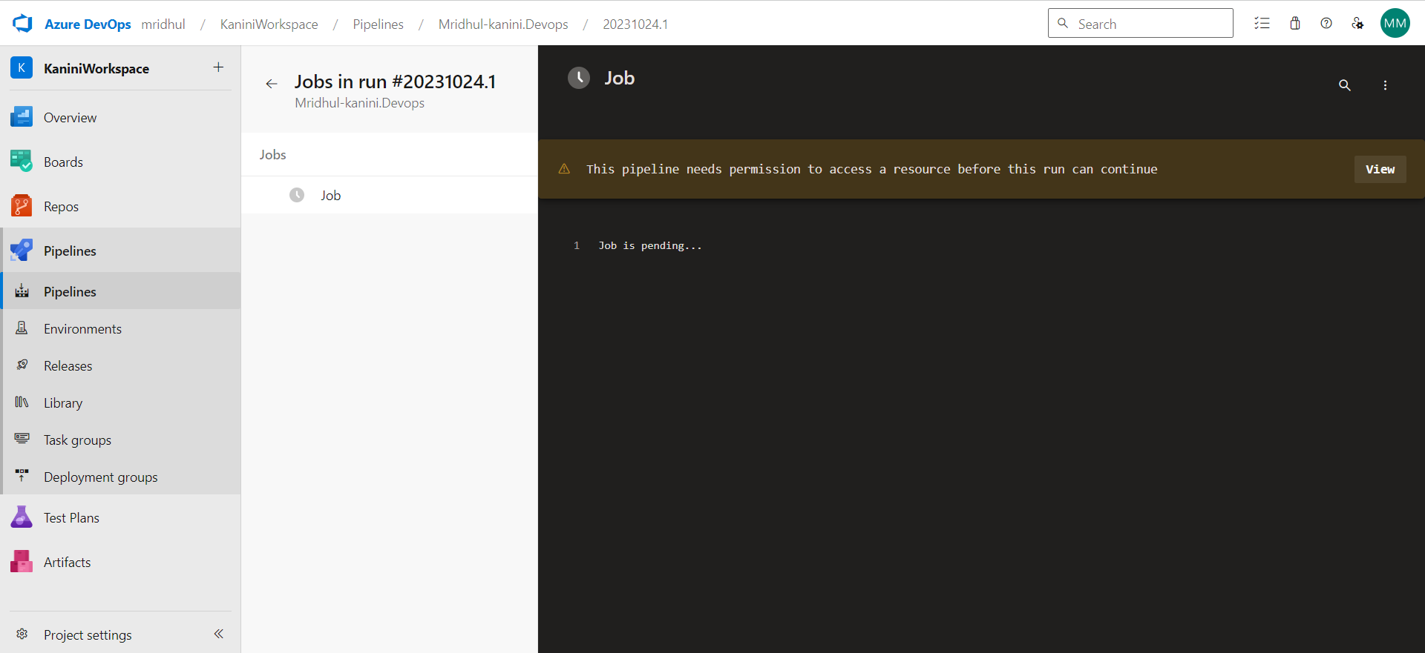

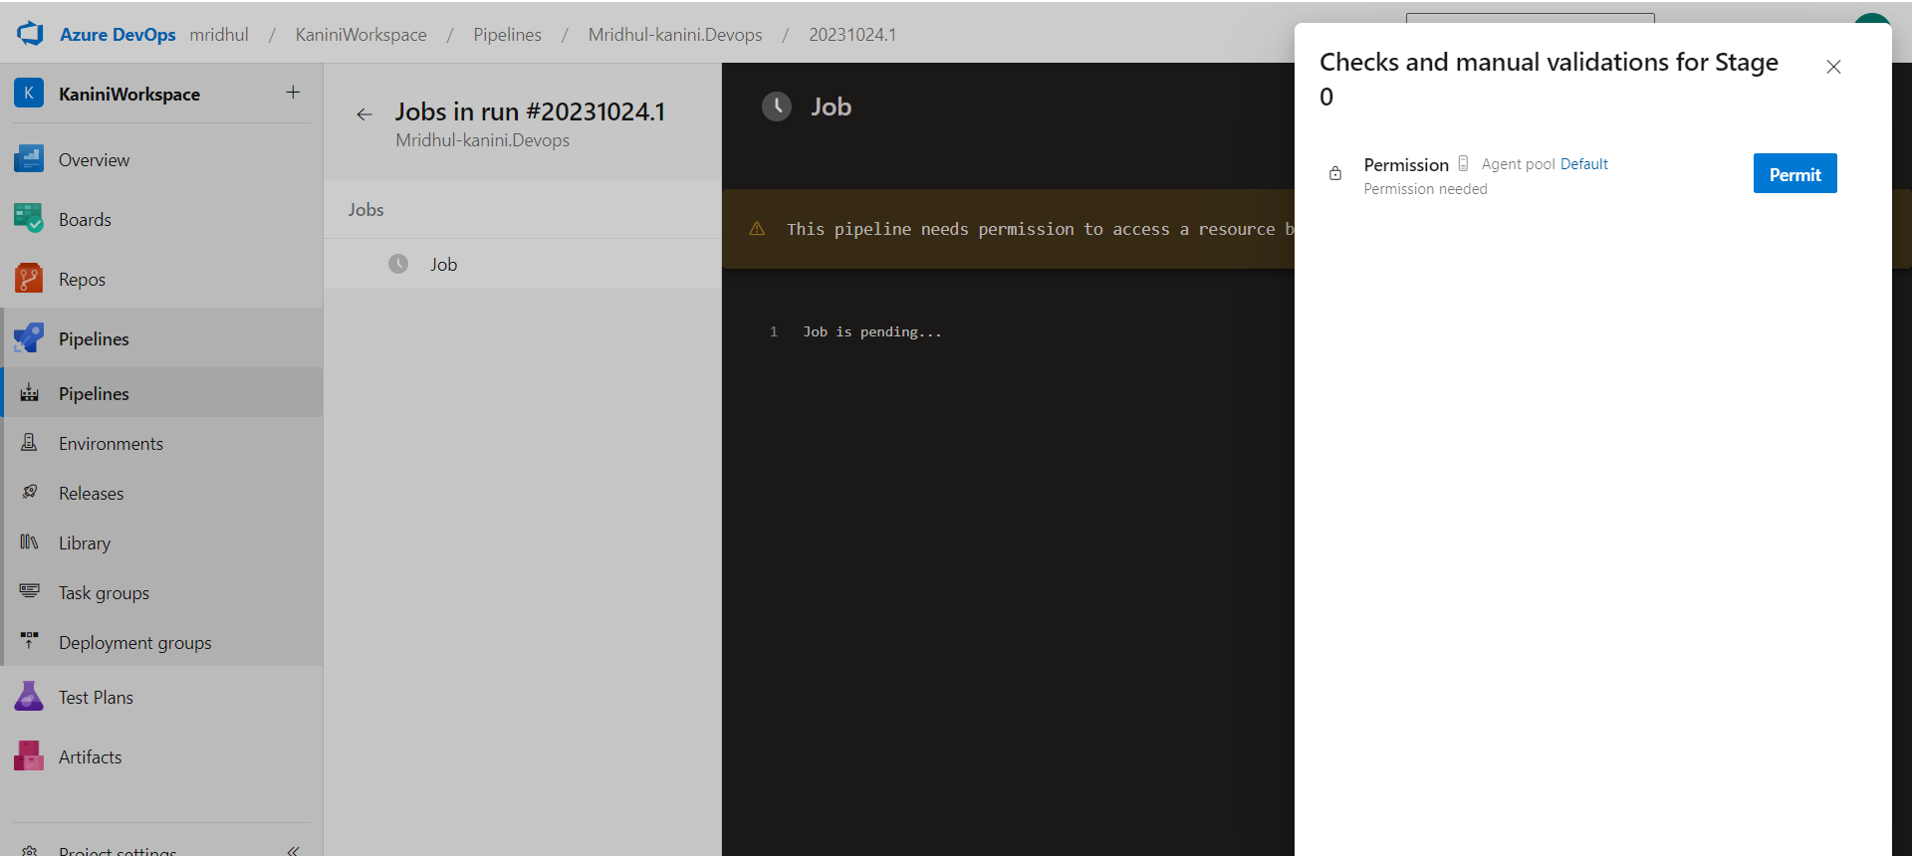

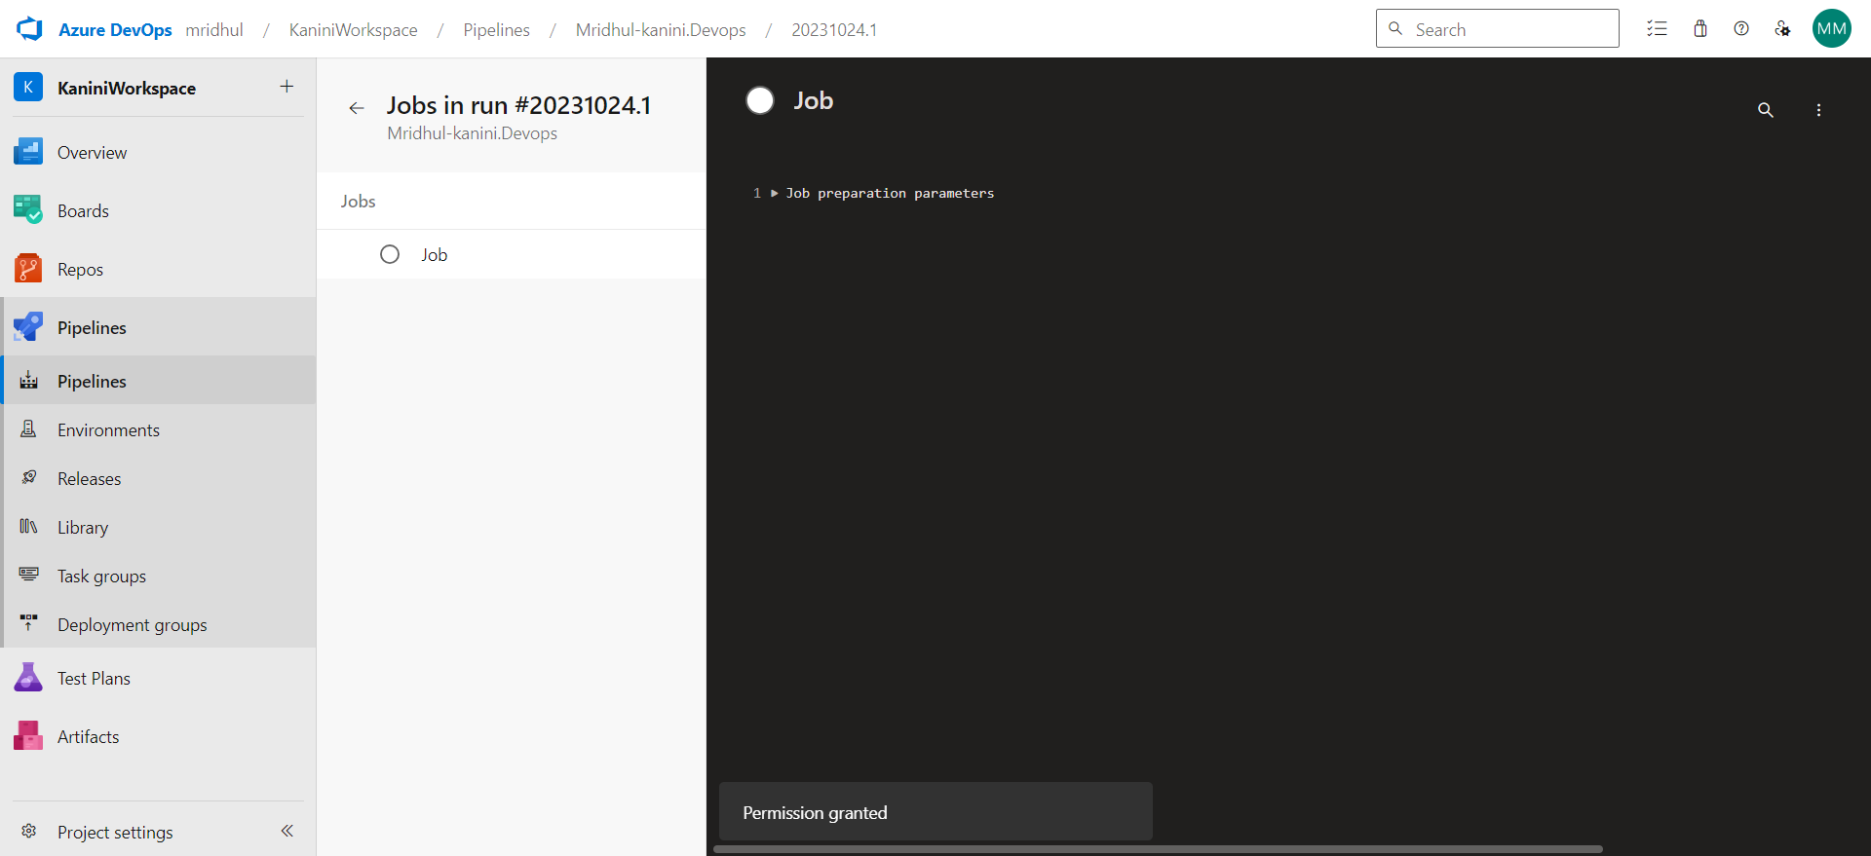

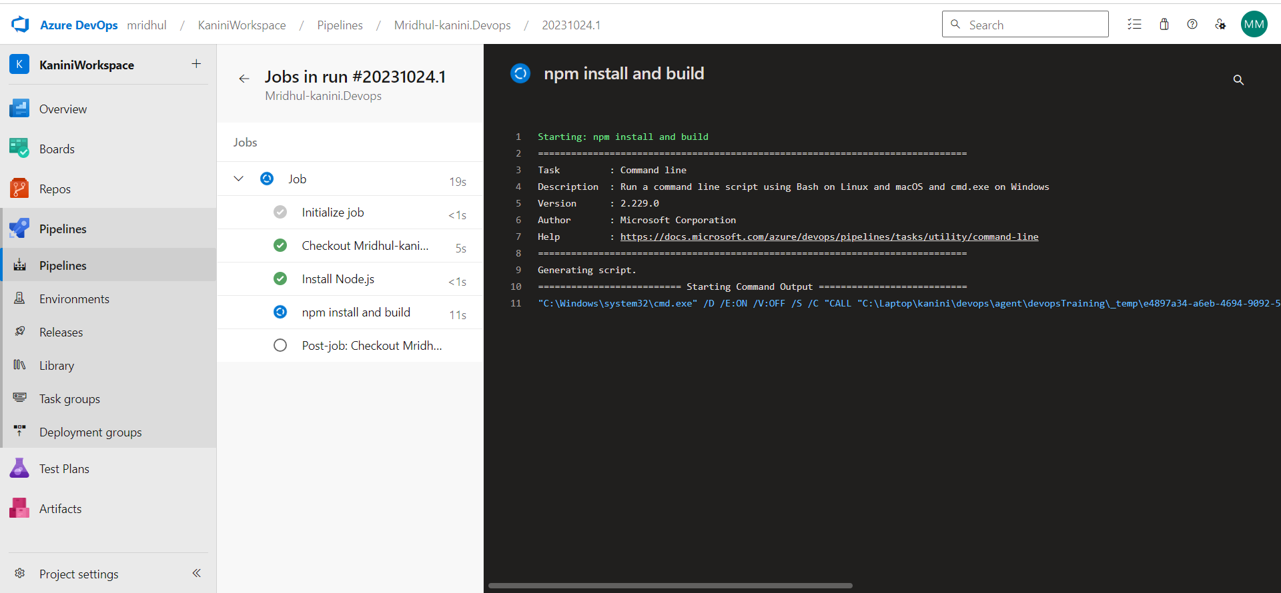

**Lab 9: Create CI Pipeline for .NET Core Application with MS Unit Test**

Objective: Create a CI pipeline, either classic or YAML, to build a .NET Core application and

run MS Unit tests.

Tasks:

1.Set up a new Azure DevOps project.

2.Create a CI/CD pipeline for a .NET Core application.

3.Configure the pipeline to use MS Unit tests.

4.Trigger the pipeline and validate the test results.



Choose Github

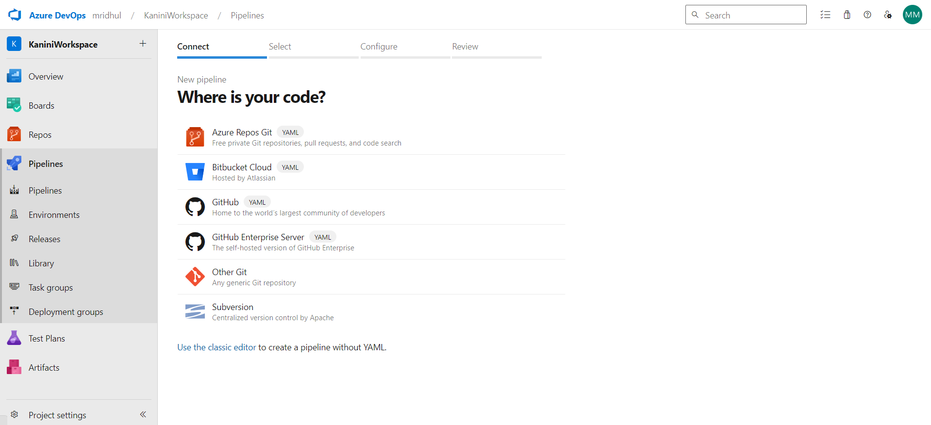

Choose Repo

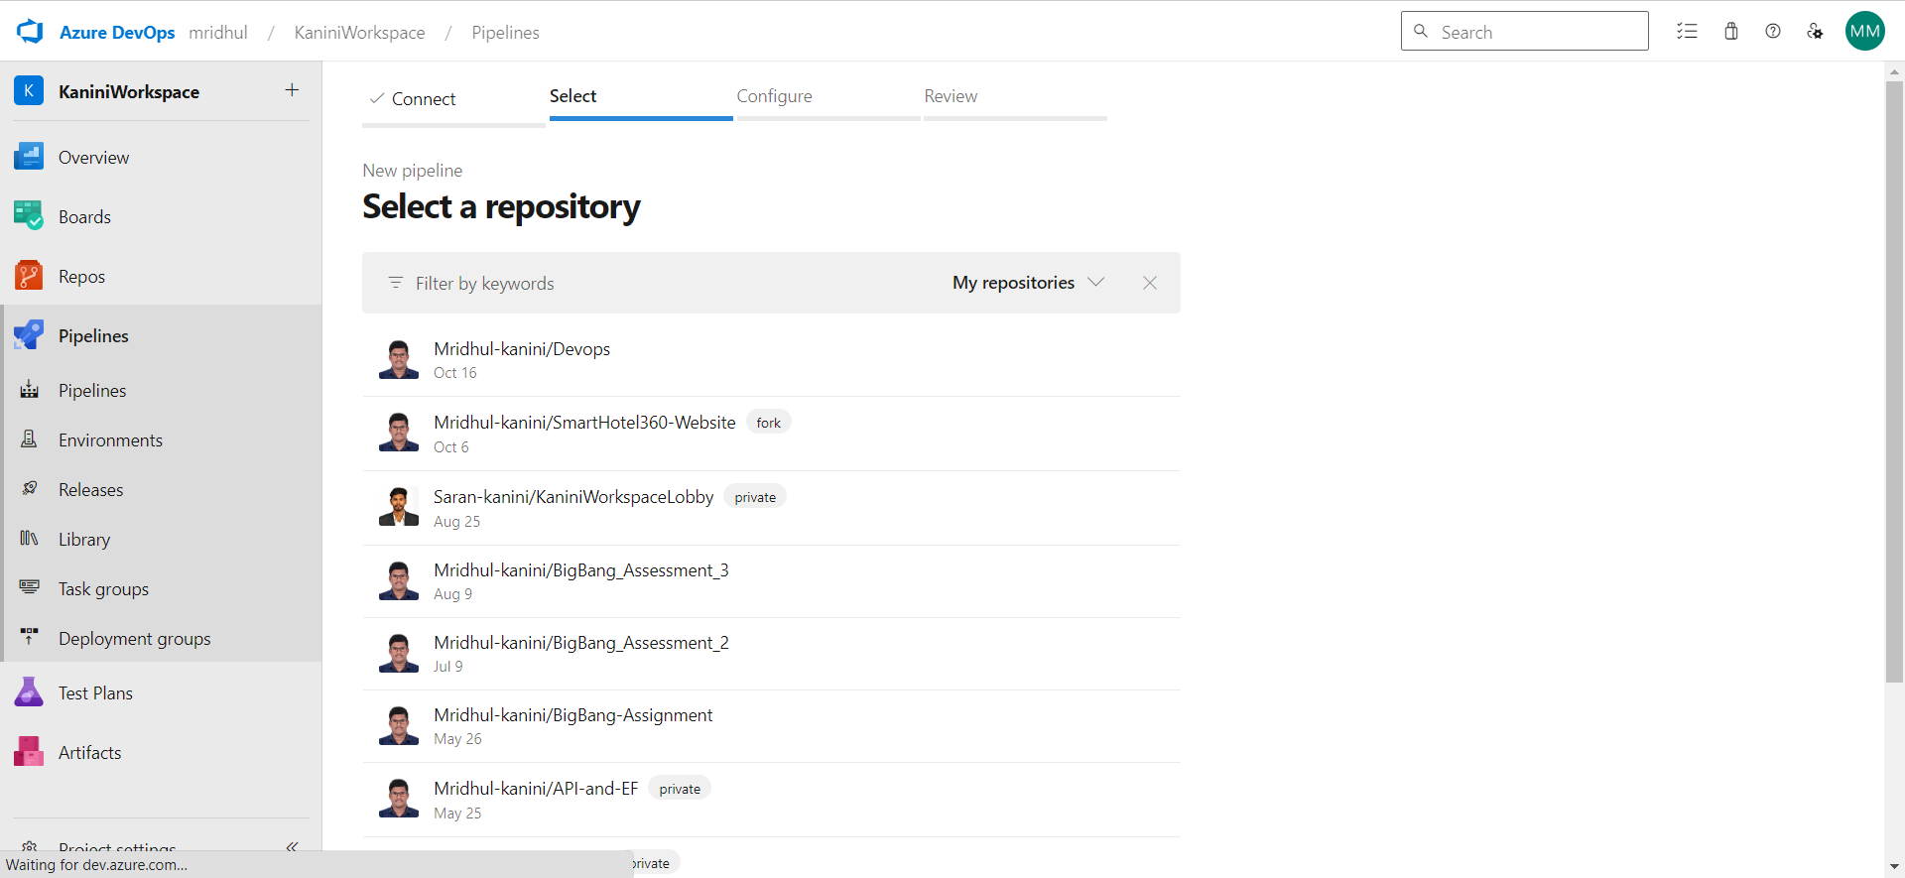

Choose ASP .net Framework

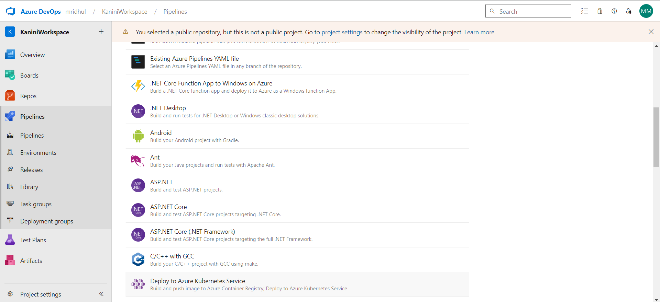

Edit yaml

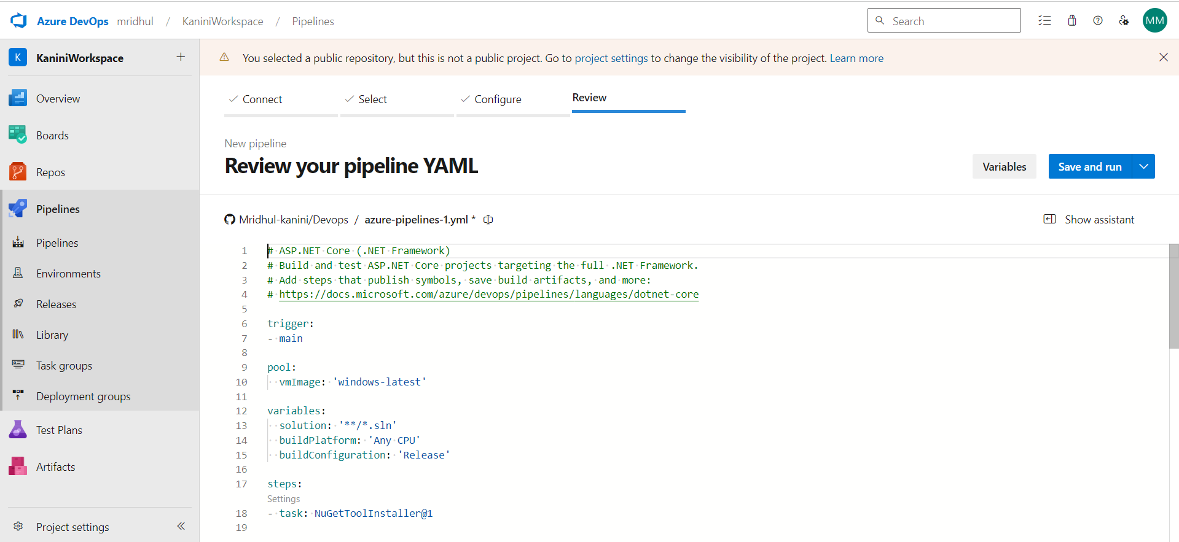

Save and run

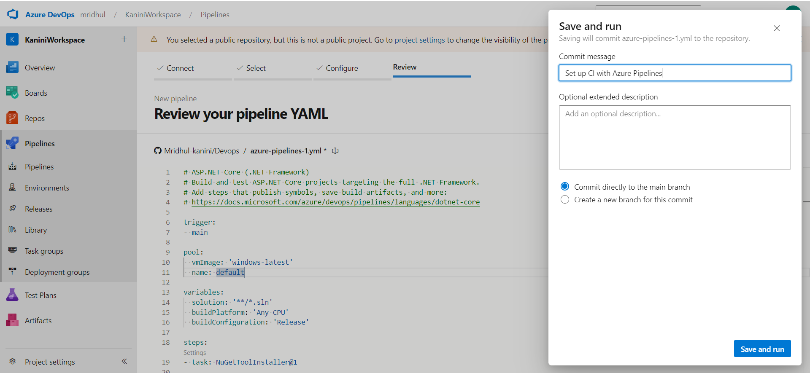

Permit

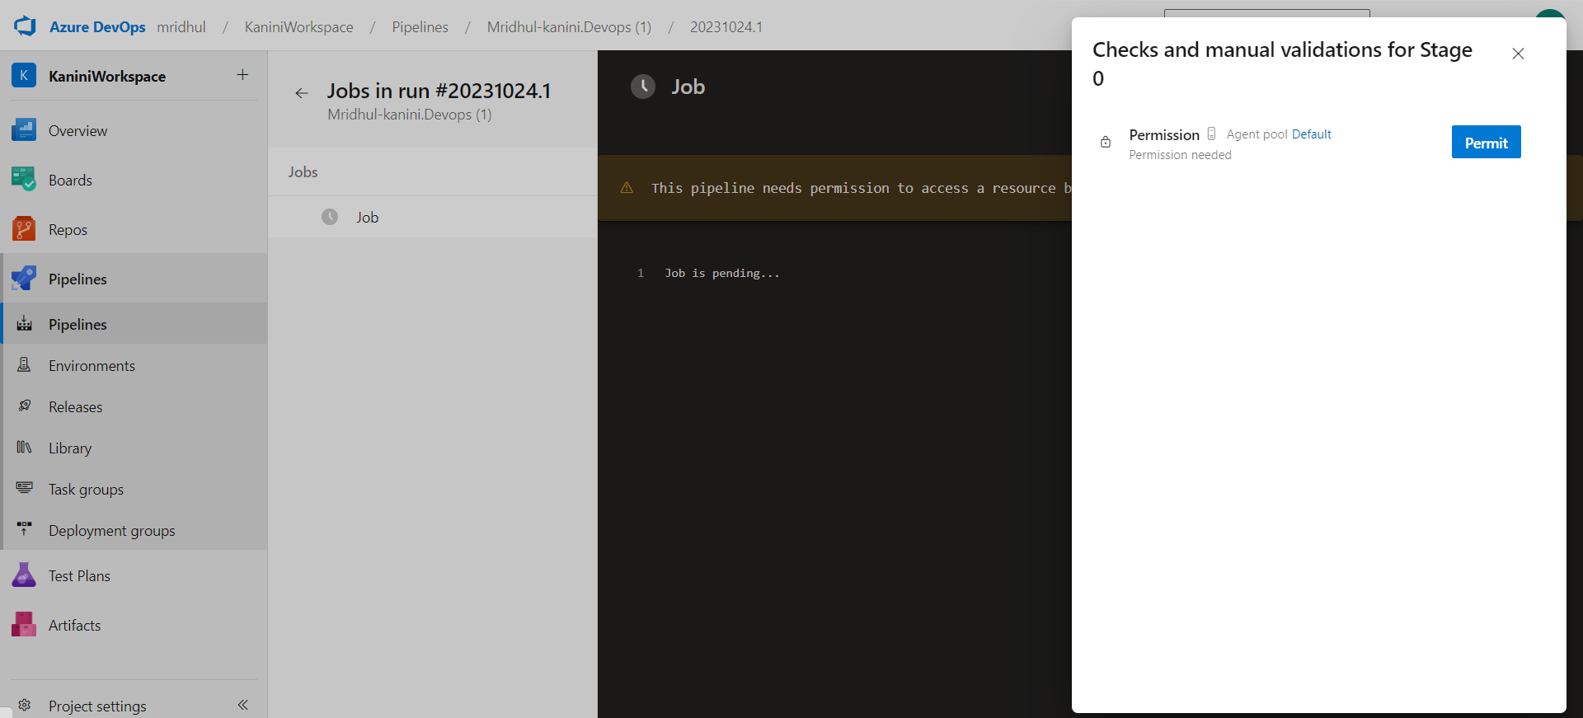

Starting Pipeline

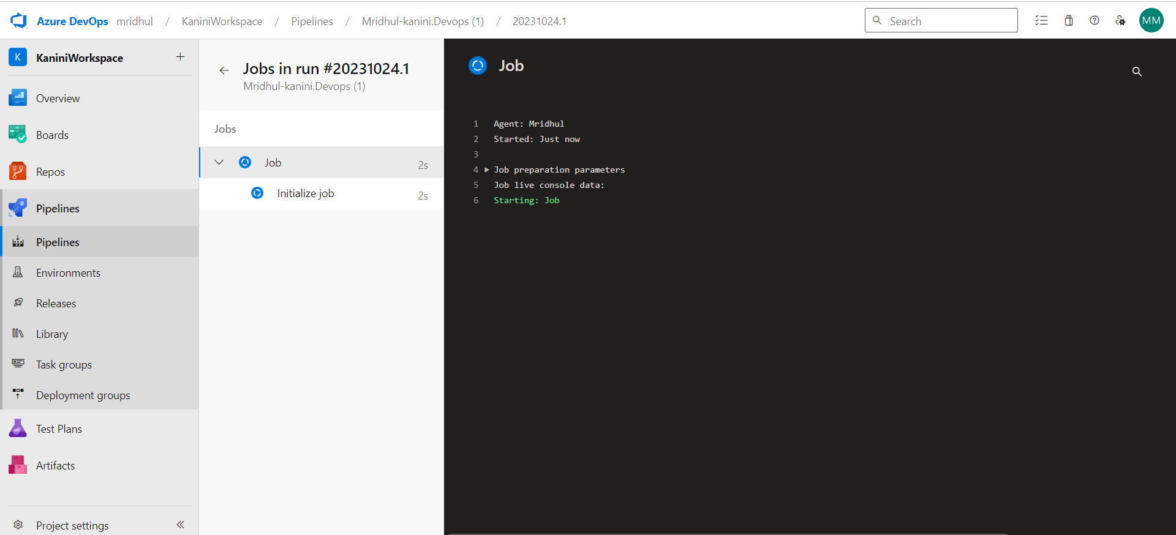

Pipeline ran successfully

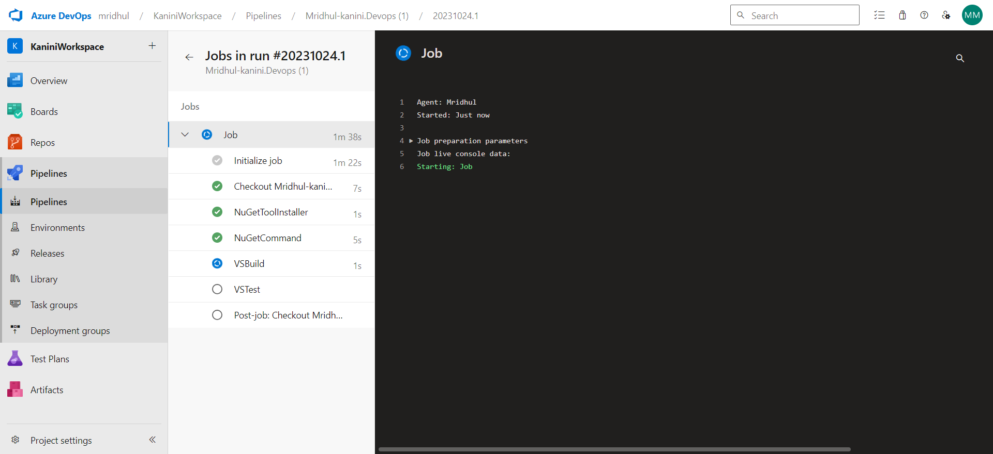

**Lab 10: Creating a Docker Image for a .NET Core Web API and Running it in**

Rancher Desktop

Objective: In this lab, you will create a Docker image for a sample .NET Core Web

API application and then run the Web API container in Rancher Desktop.

Prerequisites:

Rancher Desktop installed and running.

.NET Core SDK installed on your machine.

Tasks

Step 1: Create a .NET Core Web API Project

Step 2: Build the .NET Core Web API Project

Step 3: Dockerize the .NET Core Web API

Step 4: Build the Docker Image

Step 5: Run the Docker Container in Rancher Desktop

Step 6: Test the .NET Core Web API via swagger

Ans:

Step 1: Create a .NET Core Web API Project

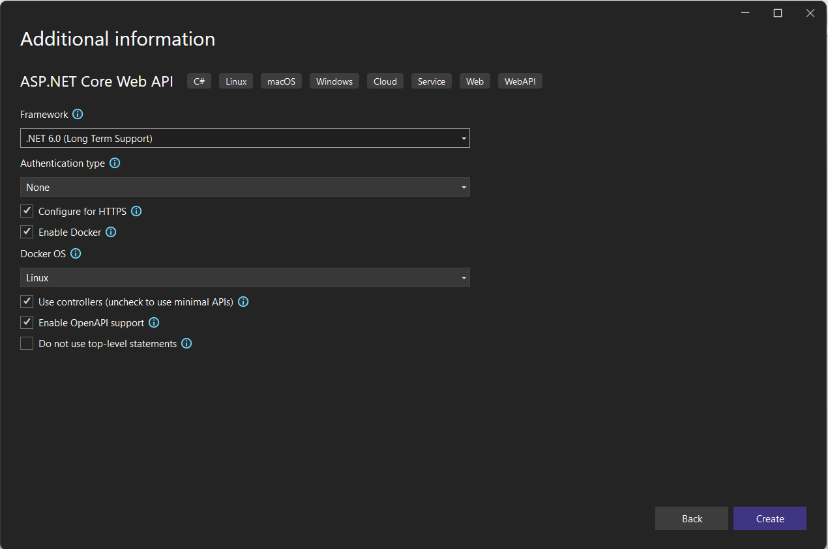

Creating Docker File

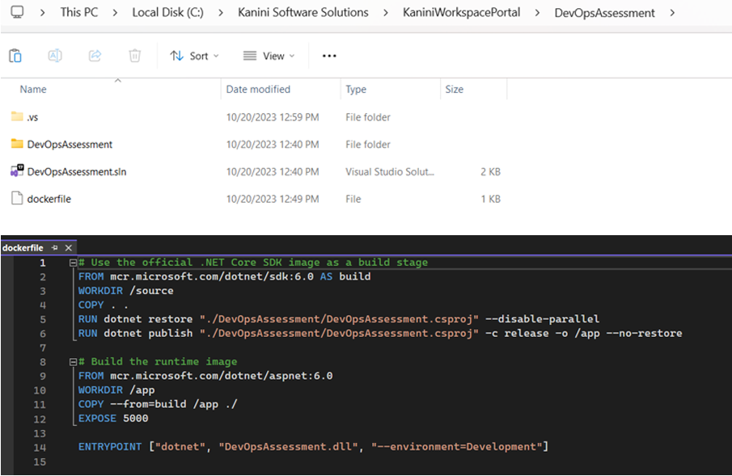

Listing All Images

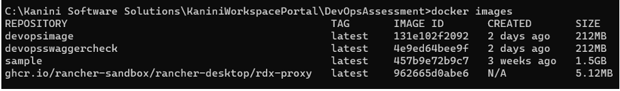

Building the docker file

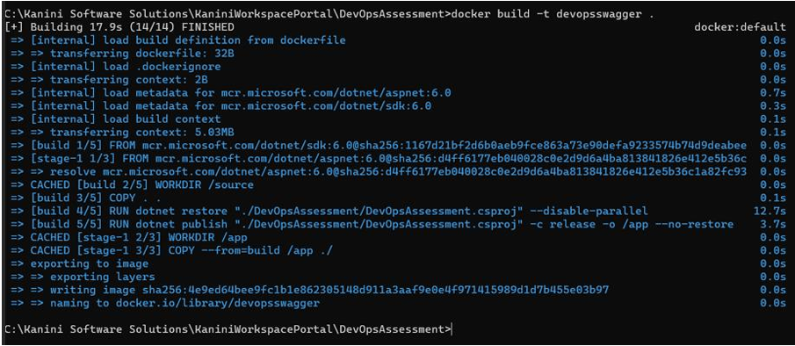

Run the Docker Container in Rancher Desktop:

You can find the docker image “devopsswaggercheck” in Rancher

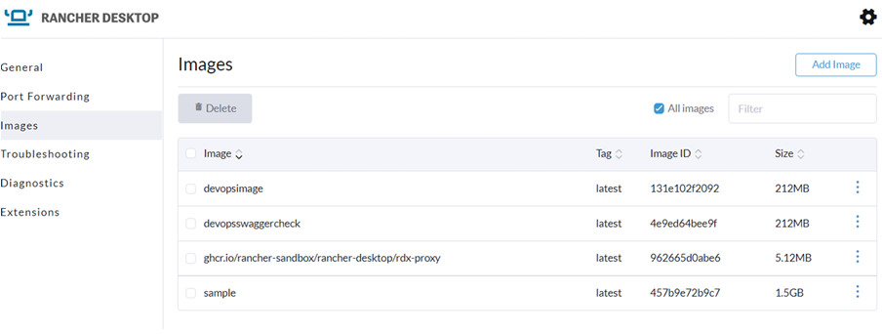

Test the .NET Core Web API via swagger

Now I am running the docker image

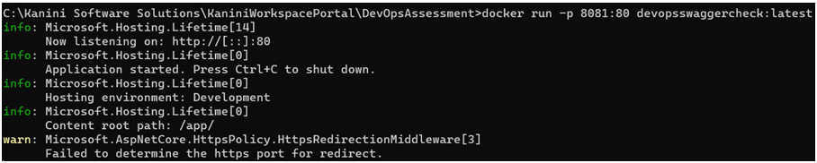

Its runs in swagger via docker

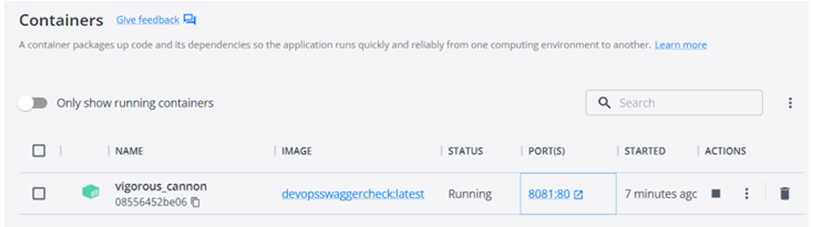

Finally the .net application runs on swagger via docker and rancher

